**Educational System**

**Elementary and Secondary Education**

-- Elementary and secondary education—the basis of public education, free and compulsory, 12 grades

-- One academic year—from September through June

-- Different divisions of school systems:

-- elementary school—one through eight

high school—next four years

-- elementary school—one through six

junior high school—seven through nine

senior high school—ten through twelve

-- Elementary education

Courses: reading, arithmetic and language arts

(creative writing, spelling and handwriting),

social studies, science, music, the arts and

physical education

Class size—20 to 30 students

-- Secondary education

-- Two stages: junior high school and senior high school

-- Courses: English classes (writing & literature), social studies (American history, American government or political science, European history), algebra & geometry, general science(biology, chemistry & physics), foreign language (French or Spanish, Chinese)

-- Nine periods for a day:

five for academic subjects

one for physical education

a lunch period

two study periods

visiting the library

participating in extracurricular activity

-- No annual college entrance examination; applicants are chosen on the basis of the following 4 aspects:

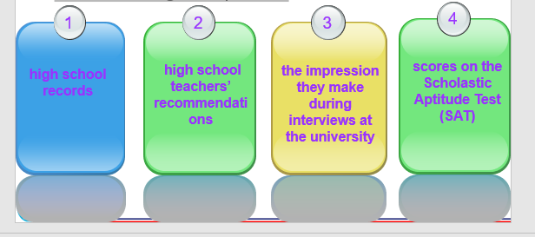

**Higher Education**

--The beginning of higher education—the founding of Harvard College in 1636

a big enterprise with a complex system

-- Four categories of institutions:

the university

the four-year undergraduate institution—the college

technical training institution

two-year community college

-- College & University

--Location of institutions

New York—308 institutions

California—299 institutions

Nevada and Wyoming—only nine institutions each

-- The variety of subjects

fine arts and practical, career-oriented fields

-- The variety of institutions

large, comprehensive universities and small traditional liberal arts colleges

-- Factors for students’ personal preferences

size, academic quality, location

reputation of the faculty and department

-- The Board

-- The board of trustees (理事)—carrying out administration of colleges and universities

-- Composed primarily of laymen (非专业人士)

Laymen—represent the public interests than professionals

-- Legal body, responsible for the institution

-- Responsibilities:

choosing the president;

establishing policies for administrators and faculty;

approving the budget;

the purchase and sale of real estate and other major property items, etc.

-- College Life

-- An academic year—nine months

two or three semesters, excluding the summer session

a “break” of one week in each semester and a 30-day winter break

-- Credits

earned by attending lectures (or lab classes) and by successfully completing assignments and examinations

one credit—one hour of class per week in a single course

a course may last 10 to 16 weeks—a semester

-- Sports—significant in university life

football—most popular

football and basketball scholarships

students as athletics or “jocks” (大学运动员) receive free tuition and other financial assistance

-- Students’ organizations—clubs and activities

help students become successful when pursuing hobbies

art, music, drama, debate

foreign languages, photography

volunteer work

**Famous Universities**

